Please complete this statement and submit it with your credit application.
- Describe how the pandemic has impacted your business and steps you have taken to lessen its impact (including: is your company open for business, how has revenue been impacted, have you had to furlough any employees, are you applying for government relief?)
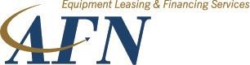
- Why are you looking to finance equipment at this time? How will it benefit your business?
COVID
-
19

BUSINESS STATEMENT

- Do you generate revenue job-by-job or under contractual agreements? How far in the future can you project your revenues today?
- Are there any major fixed costs or financial obligations that could negatively impact cash flow if your business revenue slows significantly?

